Keep Manjeet Safe in the UK

Show Solidarity – Mon 19th December

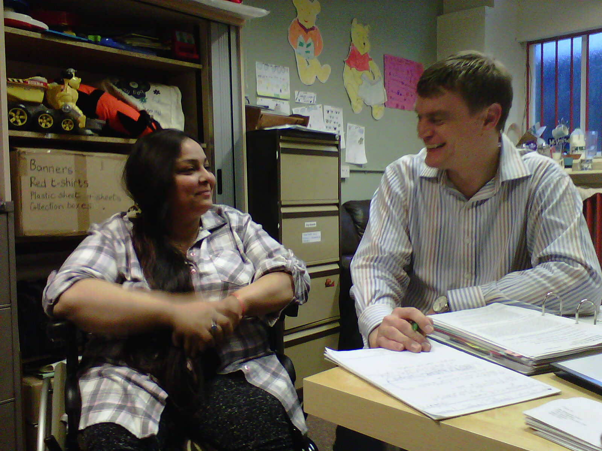

Manjeet with her lawyer, Gary McIndoe, preparing for court.

Donations from Trade Union branches and individuals in Greater Manchester has meant that Manjeet has been able to fight back legally…

For the next stage in this process we need your physical presence outside the courts…

Stand beside Manjeet at 10am on 19th December

Manchester Civil Justice Centre,
1 Bridge Street West (corner of Gartside Street),
Manchester M3 3EL

- Manjeet’s husband, Amitt Bhatt, a journalist and Kashmir human rights activist, was threatened and attacked because of his anti-government publications. He disappeared without trace in February 2011.
- Manjeet was beaten and threatened with rape and murder at her home in Delhi by people looking for her husband. This is what led Manjeet to flee.
- Manjeet uses a wheelchair due to paralysis from polio: the injuries sustained from the attacks have worsened her condition.
- When she fled from India in March 2011 Manjeet was in fear for her life. She came to the UK to be with several family members who can offer her support.
- At this time, the UKBA has refused her asylum claim and Manjeet is facing the threat of deportation to India: Being bound to her wheelchair in a country where 90% of the infrastructure is wheelchair inaccessible will severely diminish her ability to protect herself.
For more on Manjeet’s campaign see:
www.rapar.org.uk/keep-manjeet-safe-in-the-uk.html
